# Story W14. Log out

As a user   
I want to logout   
so that nobody can pretend to be me

## Wireframes:

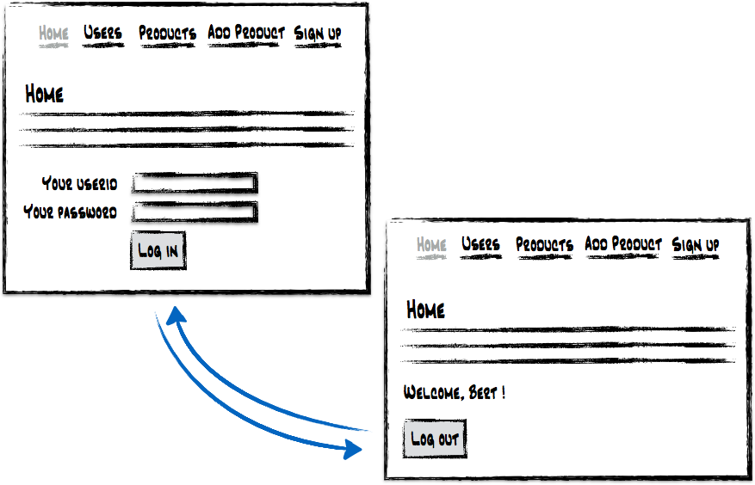

## Technical details

Create a method *logout()* in the servlet that will destroy the session.

## Acceptance criteria:

* If a person logs out, the user is redirected to the index page
* The index page shows the login form again
* The name of the user and the logout button is not visible anymore